Walkthrough 21 Data Types

https://sapui5.hana.ondemand.com/#/topic/dfe04650afc046e0802abb1a1a90d2d9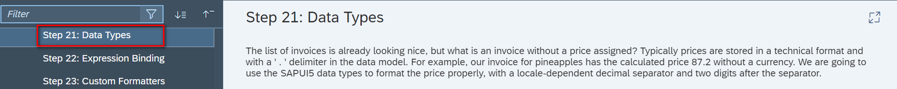

Core Changed Codes Compared to Last Version:

InvoiceList.controller.js 新建InvoiceList视图控制器

定义货币模型

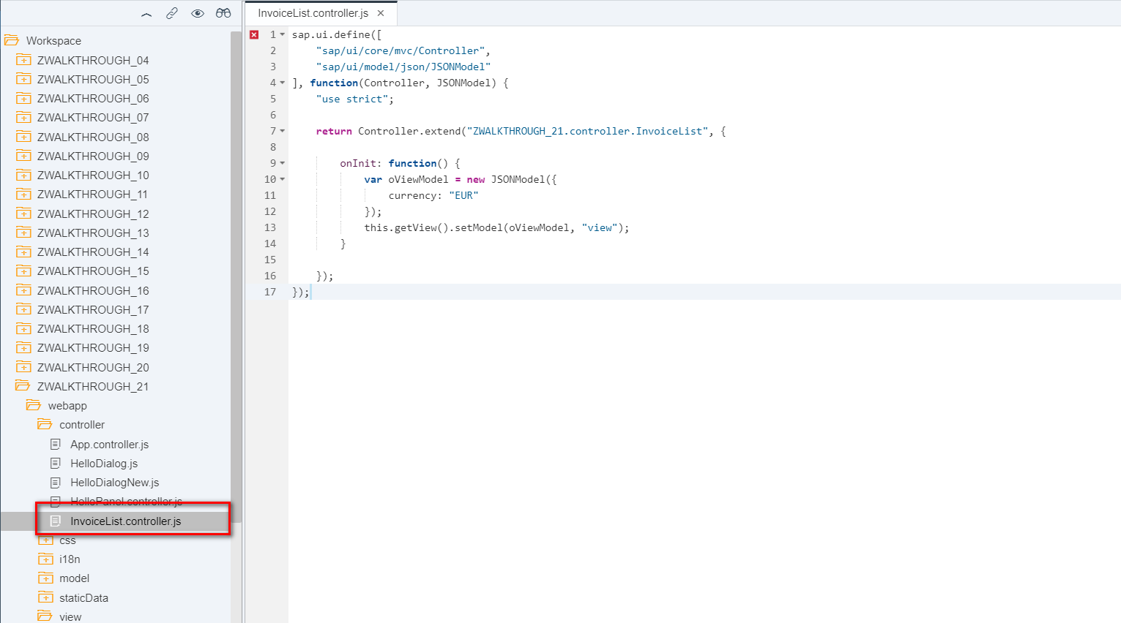

InvoiceList.view.xml

分配视图控制器InvoiceList.controller.js,增加数值【number】以及数值单位【numberUnit】属性

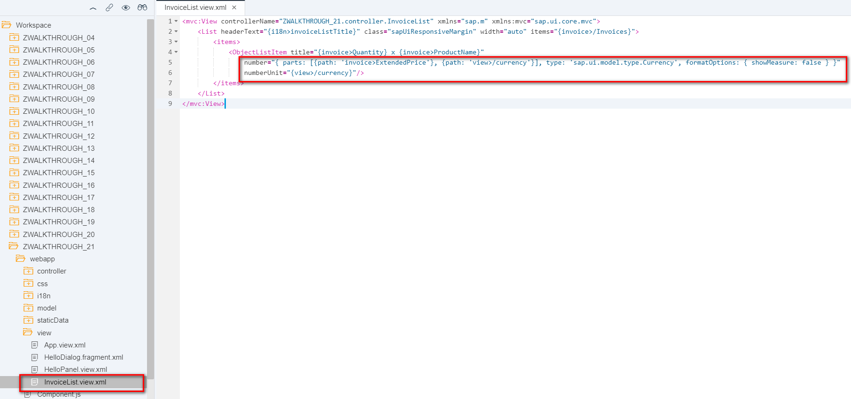

i18n 文本对象管理

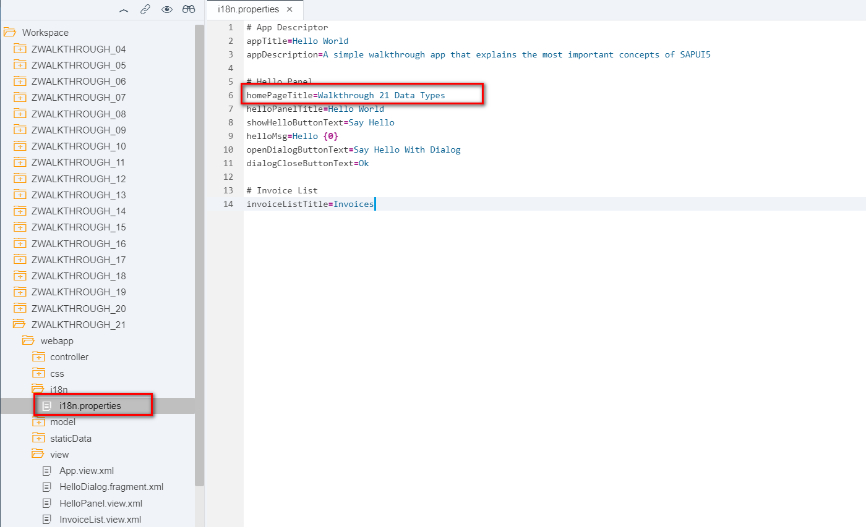

Result

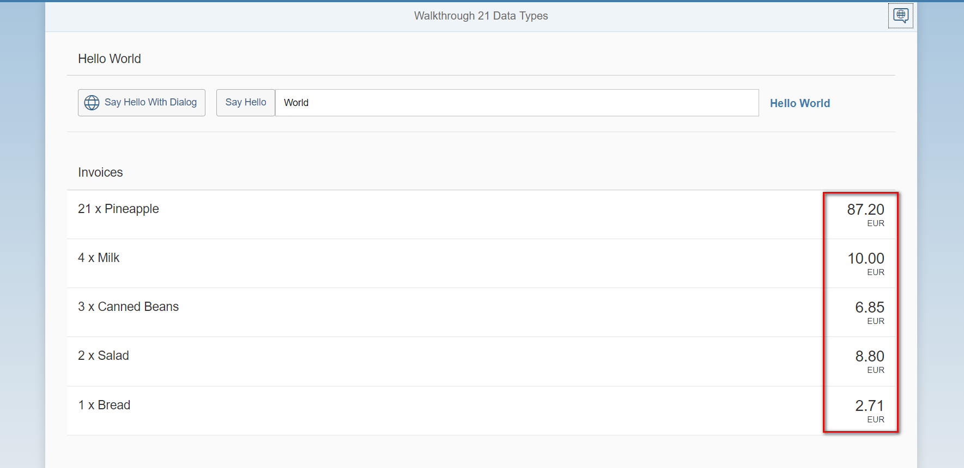

Git:

https://github.com/xiexiaop/SAPUI5-2-Round/tree/master/Projects/ZWALKTHROUGH_21

2019/02/01 XiaoMi Beijing Zac,Xie